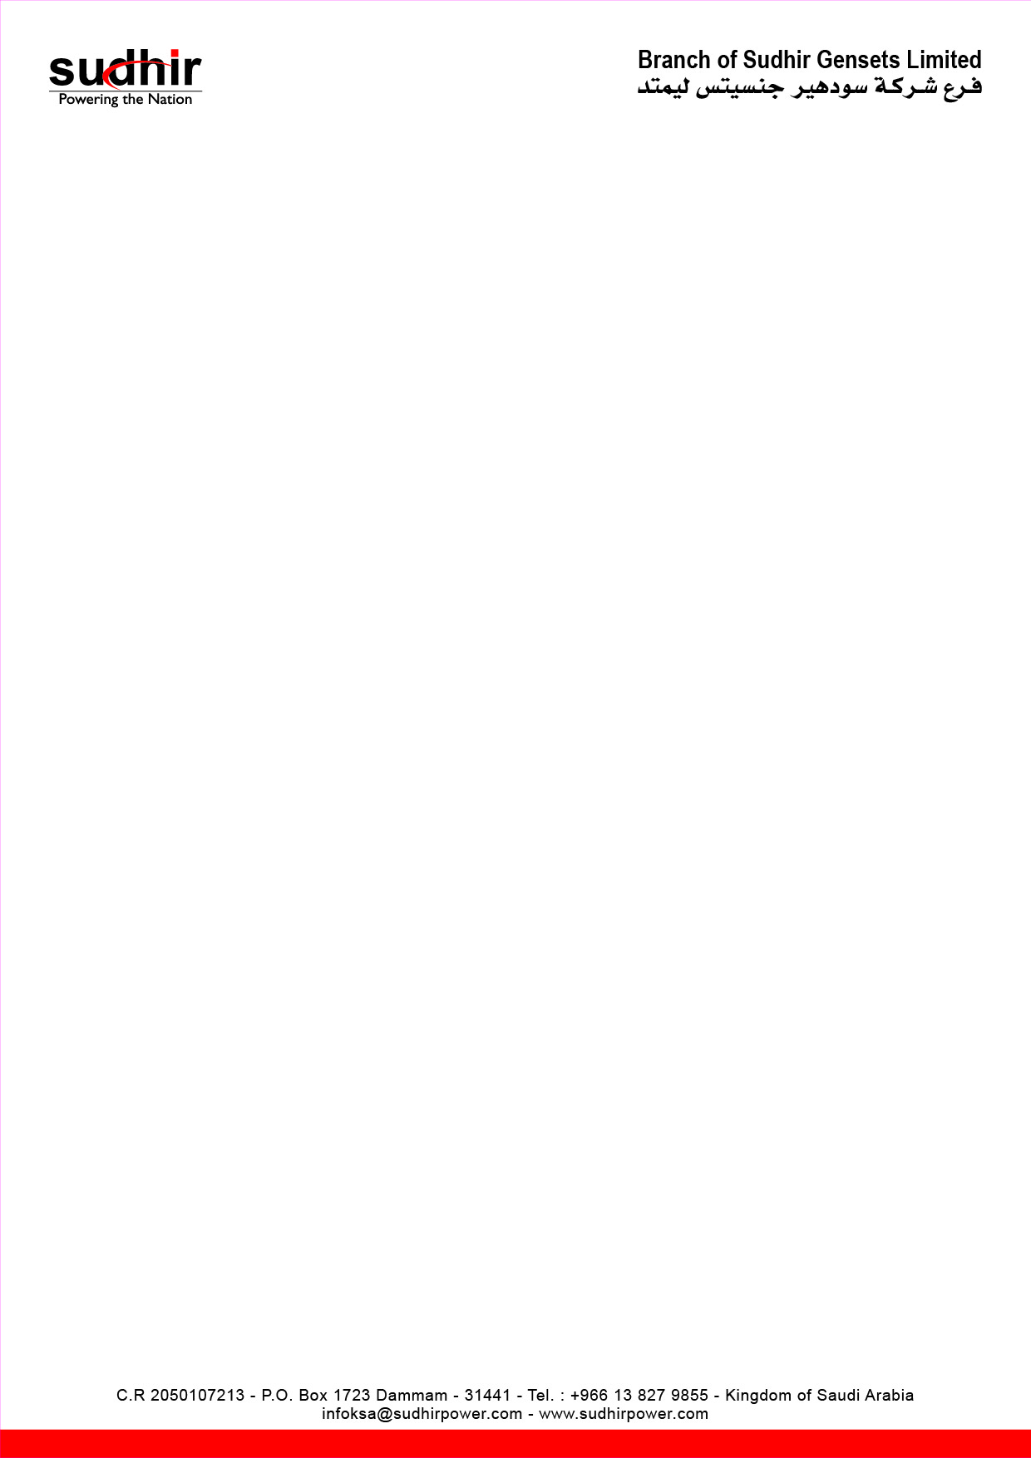

Ownership Certificate

To Whom It May Concern

This is to certify that the following equipment mentioned below are the sole owned by
Branch of Sudhir Gensets LTD.

Equipment | Diesel Soundproof Generator
Brand / Make | Cummins
Asset ID | SG-367-300
Model Number | PI313C
Serial Number | G17PI503566
Engine Serial Number | 84507982
Rating | 284KVA/227KW

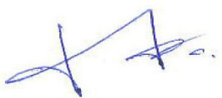
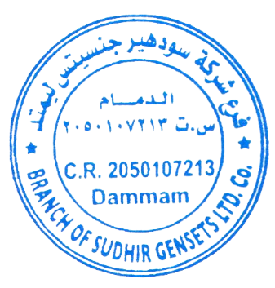
Mansoor Ali
Branch Manager
Branch of Sudhir Gensets LTD. Co
Dammam - KSA

